EE113D: Digital Signal Processing Design

Lab 1: Waveform Generation and Measurement

Objective:

The objective of Lab 1 is to introduce the hardware and software functionality of the STM32 Nucleo board through the generation of sinusoidal waves in C. More specifically, the lab focuses on the use of the debugger and the trace function for data verification.

STEP 1:

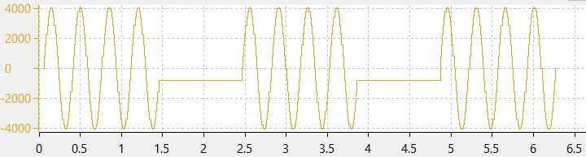

Fig. 1: Figure of the 3 generated sine waves. The first wave is generated through the math library.

CODE:

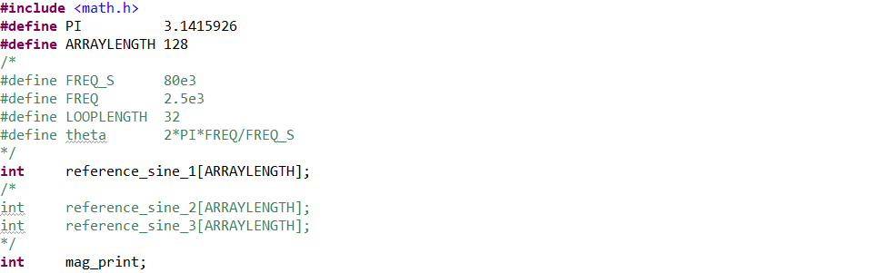

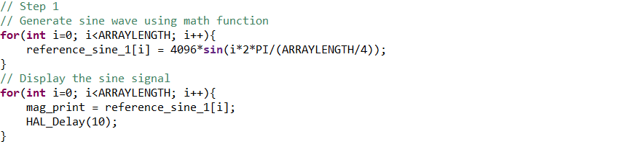

STEP 2:



Fig. 2: Figure of the 3 generated sine waves. The second wave is generated through a look-up table.

CODE:

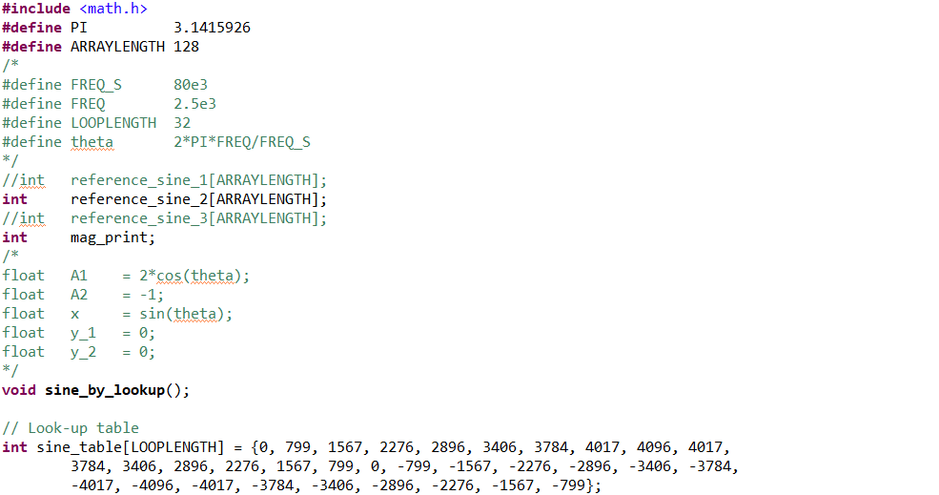



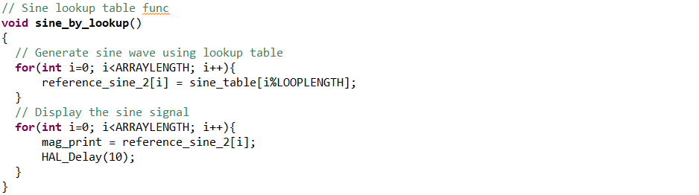

STEP 3:



Fig. 3: Figure of the 3 generated sine waves. The third wave is generated through the difference equation:

$$y\left(n\right)=x\left(n\right)+2\cos\left(θ\right)y\left(n-1\right)-y(n-2)$$

CODE:

